1. WebDriver Interface

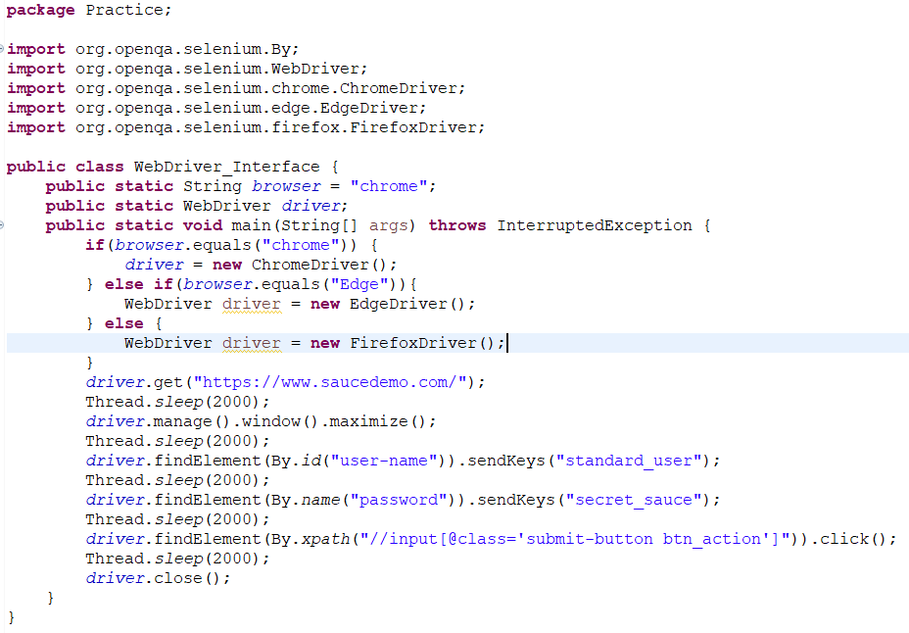

1. Locators in Selenium WebDriver

There are 8 locators in Selenium WebDriver.

* Id
* Name
* Link text
* Partial Link text
* CSS selector
* XPath
* Tag name
* Class name

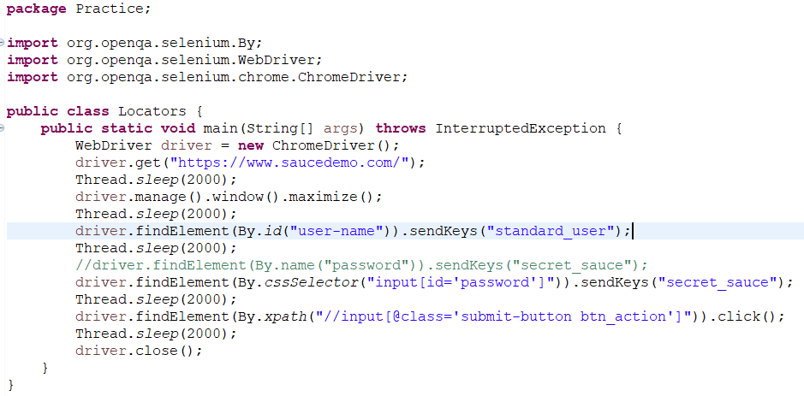

1. Relative locator in Selenium

Selenium 4 brings the relative locators. These are the also called as friendly locators.

Types of Relative locators are –

* Above
* Below
* To left off.
* Ro right off
* Near

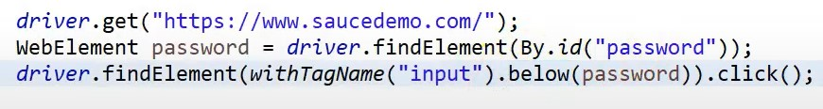

1. Basic XPath

* XPath stands for XML path language.
* XPath is used to find the location of any element on a webpage using HTML DOM structure.
* It was defined by the World Web Consortium(W3C).

XPath = //tagname[@attribute=’value’]

1. Relative Vs Absolute XPath

* Relative XPath –

XPath starts from the mid of the HTML DOM structure.

It begins with double forward slash (//).

* Absolute XPath –
* It contains the complete path from the root element of the page to the desired element.
* Absolute XPath stands with root node – Single forward slash (/).

1. CSS Selector

* Faster than XPath, because it follows DOM structure.
* Performance is much better.
* We cannot move backward or reverse.

tagname[attribute=’value’]

1. Basic Methods in Selenium WebDriver Interface:

* get(java.lang.String url)

Load a new webpage in the current window browser.

* manage()

Gets the option interface.

* getCurrentUrl()

Get a string representing the current URL that the browser is looking at.

* getTitle()

The title of the current page.

* getPageSource()

Get the source of the last loaded page.

* navigate()

An abstraction allowing the driver to access the browsers history and to navigate to a given URL.

* quit()

Quits this driver, closing every associated window.

* close()

Close the current window, quitting the browser if it’s the last window currently open.

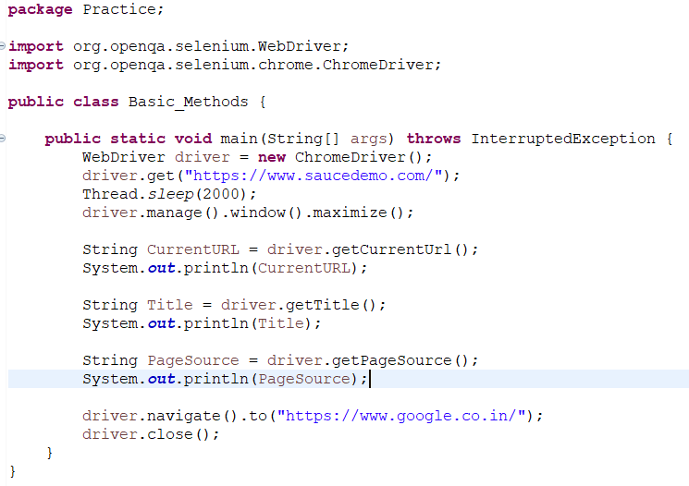

* getWindowHandle()

Returns the opaque handle to this window that uniquely identifies it within this driver instance.

* getWindowHandles()

Returns a set of window handles which can be used to iterate over all open windows of this driver instance by passing then to switchTo().WebDriver.Options.window().

* switchTo()

Send future commands to a different frame or window.

* findElement(By by)

Find the first web element using the given method.

* FindElements(By by)

Find all elements within the current page using the given mechanism.

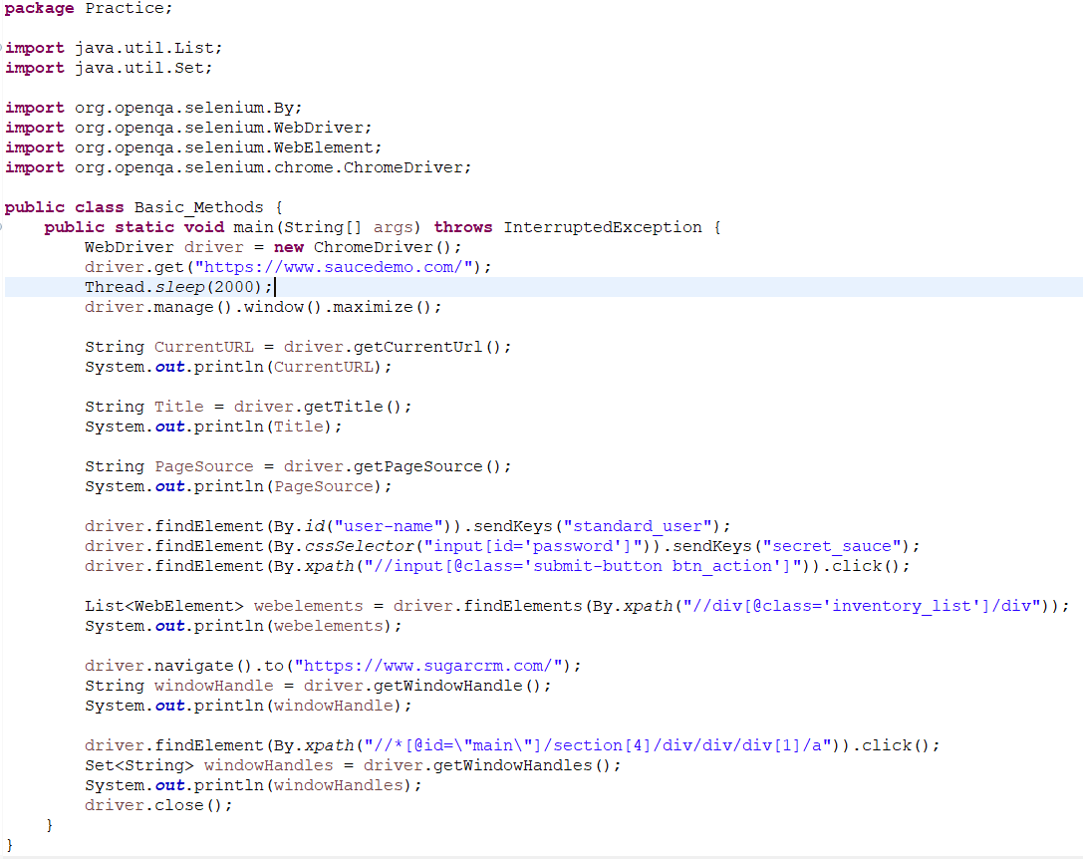

1. WebElement Methods

There are three WebElement methods in Selenium.

* click()
* sendKeys()
* submit()